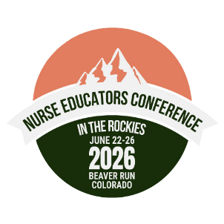

JUSTIFICATION LETTER & EXPENSE WORKSHEET
FOR THE NURSE EDUCATORS CONFERENCE
IN THE ROCKIES 2026

The Nurse Educators Conference in the Rockies is the event that nurse educators should not miss! By participating in this conference, educators will be exposed to the latest nursing education advancements, forge meaningful connections, and engage in professional development opportunities that are essential for enhancing their teaching practices. This conference promises to empower nurse educators to revolutionize nursing education, inspire future generations of nurses, and ultimately contribute to the improvement of healthcare worldwide.
We strongly urge all nurse educators to seize this extraordinary opportunity and join us in Breckenridge for an unforgettable educational experience.

Charting our True North: Navigating the Future of Nursing Education
Charting our True North: Navigating the Future of Nursing Education captures the essence of guiding the future of nursing education with clarity, purpose, and direction. It reflects the vital role that nursing educators play in charting the path forward, navigating the evolving challenges of healthcare, and ensuring that nursing professionals remain grounded in their core values, even in uncertain times.

https://www.necintherockies.com/

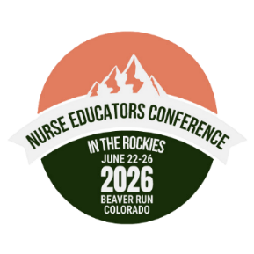

Dear [leader’s name]:
To further my knowledge regarding the latest innovations and best practices in nursing education, I would like to attend the Nurse Educators Conference in the Rockies in Breckenridge, Colorado June 22 – 26, 2026. This conference will provide a great opportunity for me to engage in professional development opportunities that are essential for enhancing my teaching practices. This conference empowers nurse educators to revolutionize nursing education, inspire future generations of nurses, and ultimately contribute to the improvement of healthcare worldwide.

Here’s how the conference can benefit my team based on the theme of Charting our True North: Navigating the Future of Nursing Education.

Meaningful Connections:
- Network with over 350 fellow nurse educators from across the country to share, learn, and collaborate on the future of nursing education
- Connection time with over 25 exhibitors specializing in nursing education that will allow me to identify new products and services that could enhance our program
- Interactive poster sessions featuring over 30 poster presentations
- Networking meals and an evening reception to foster additional relationships and explore best practices in nursing education

Timely Topics:
- Two days of interactive preconference workshops
- Powerful keynote sessions to navigate the future of nursing education
- Over 50 concurrent sessions to choose from on topics such as Professional Development for Clinical Practice, Classroom and Clinical Teaching and Learning, Faculty Development, Instructional Technology Strategies, and Course, Curriculum and Program Evaluation
- Conference session documents will be available for 60 days post conference

A detailed cost breakdown is attached. It includes the registration fee as well as travel, hotel, and transportation expenses.

I hope you’ll agree the 2026 Nurse Educators Conference in the Rockies is a wise investment that we can’t afford to miss!

Thank you for your consideration.
[Your Name]
Expense | Explanation | Cost
Registration Fees  make sure to include any additional fees associated with any pre-conferences you wish to attend | Registration Fees  1.  2.  3. | $
Airfare |  | $
Lodging/Hotel | Number of nights, room rate, and taxes | $
Transportation | Shuttle or Rental Car | $
Mileage/Parking | Parking $12/night if staying at Beaver Run  Mileage from DIA to Breckenridge: 100 miles | $
Food Per Diem | Per company. See registration page to see which meals are covered at the conference | $
Total |  | $

